**Experiment no. 4**

**Write an Embedded C program for sorting the numbers in ascending and descending order.**

**Algorithm :**

1. Initialized ptr to point to first element in array stored in internal program memory.
2. Initialize R0 to point to location 30h in internal data memory
3. Initialize count to number of elements to transfer from internal program memory to internal data memory.
4. Transfer data byte by byte from internal program memory to internal data memory for count number of times
5. Initialize outer loop counter for sorting (bubble sort)
6. Initialize internal loop counter for number of comparisons
7. Initialize R0 to point to 30H internal data memory location
8. Transfer first number in b and second number in a register
9. Compare a and b register contents, if equal goto step 12
10. If a register contents are greater then goto step 12
11. If b register contents are greater then swap contents of a and b register
12. Decrement internal comparison count. If not zero goto step 8
13. Decrement outer loop counter. If it is not zero goto step 6

**Flowchart :**

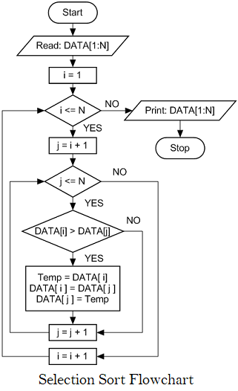

**/* Sorting the array */**

#include <stdio.h>

#include <stdlib.h>

#include <pic18f4550.h>

void main(void) {

int i,j,temp;

int num_asc[] = {10,2,5,1,6};

for(i=0; i<=4; i++){ // point to LHS number

for(j=i+1;j<=4;j++) // point to RHS number

if (num_asc[i] > num_asc[j]){ // if LHS > RHS , change the position

temp = num_asc[i];

num_asc[i] =num_asc[j];

num_asc[j]= temp;

}

}

}